

**DISPLAY SCREEN EQUIPMENT RISK ASSESSMENT**

Employees and students who are employed to carry out research or are on work experience at the University of Warwick are required to complete a separate form which can be found with other DSE training material on <http://www2.warwick.ac.uk/fac/sci/eng/local/hands/dse/>. Reference to these pages may also be helpful to students completing this form.

**Name of student completing the checklist:**

**Date of assessment:**

**Location of main workstation to be used (if possible):**

**Further action needed: YES/NO**

As stated, work through the checklist, ticking the `yes’ or `no’ column against each risk factor:

* `Yes’ answers require no further action.
* `No’ answers will require further investigation and/or remedial action. This is where hazards have been identified that could potentially introduce risks to you, the user of the workstation. You should record your decisions in the `Action to take’ column. If there are any particular issues that you are unable to resolve yourself, additional support can be provided through your supervisor, which should be indicated on the form. This is particularly relevant if you need specialist support to enable you to complete your project.

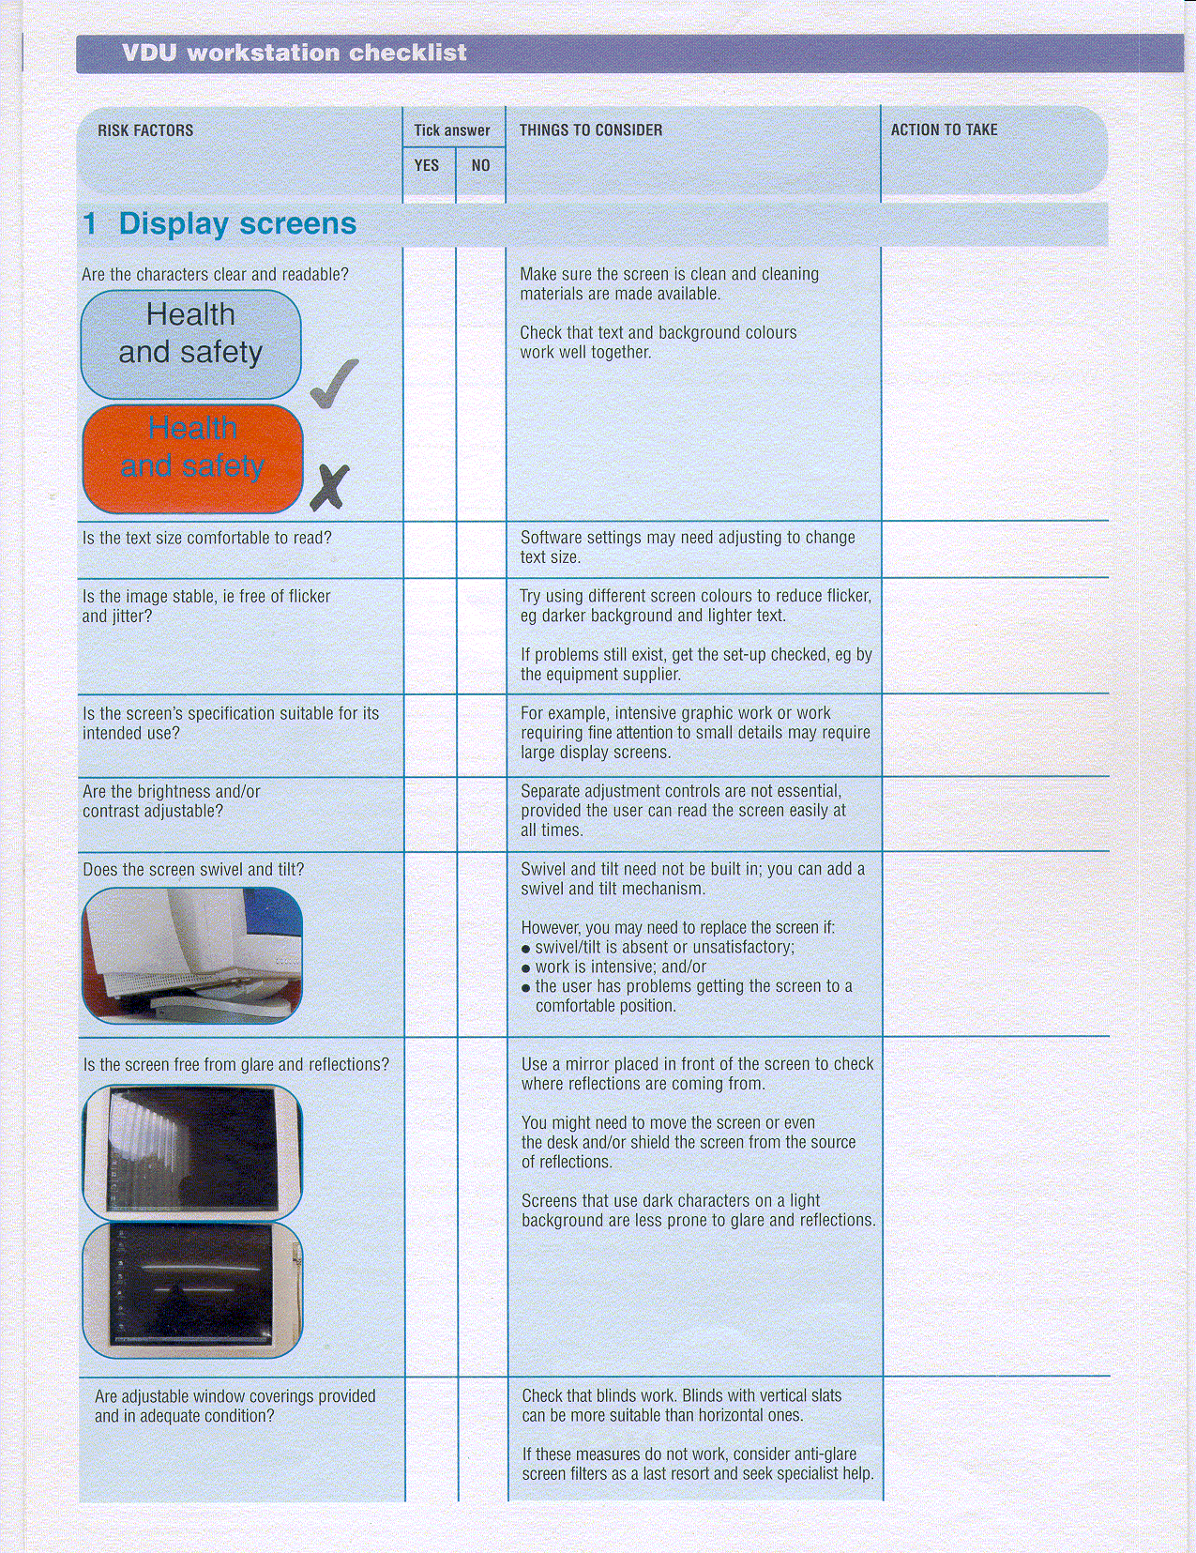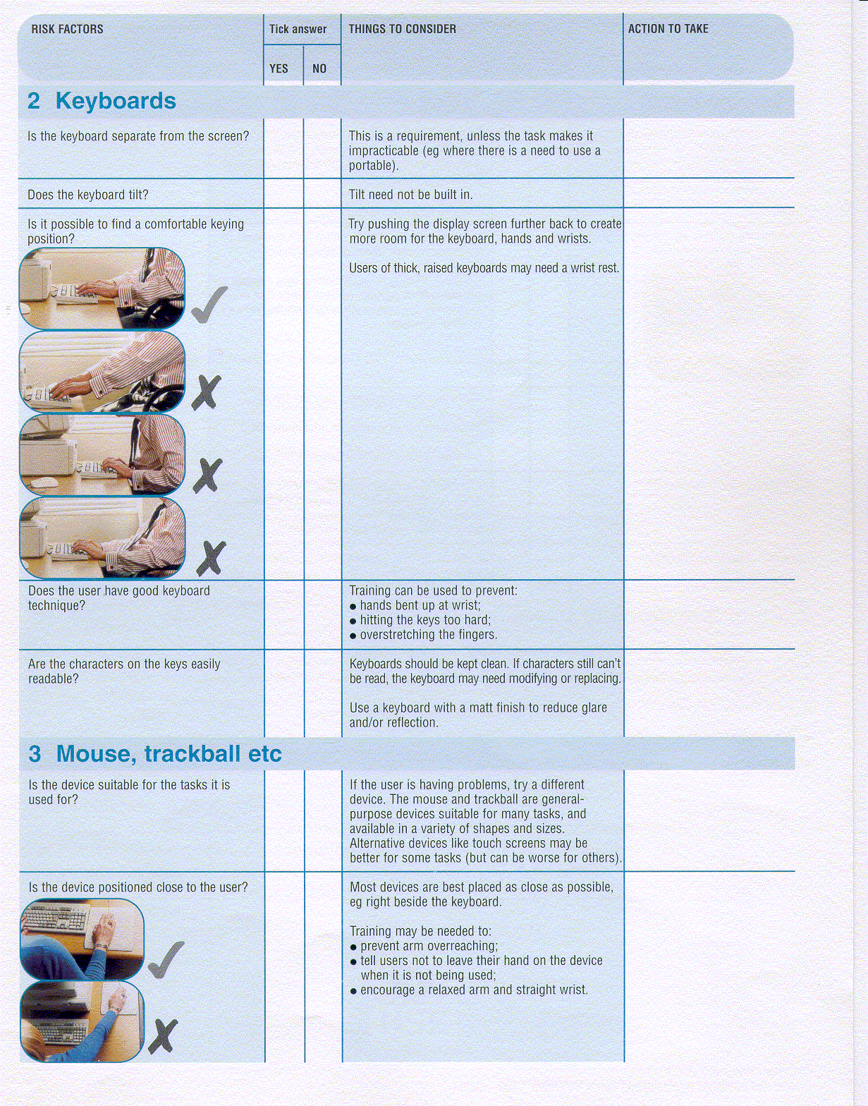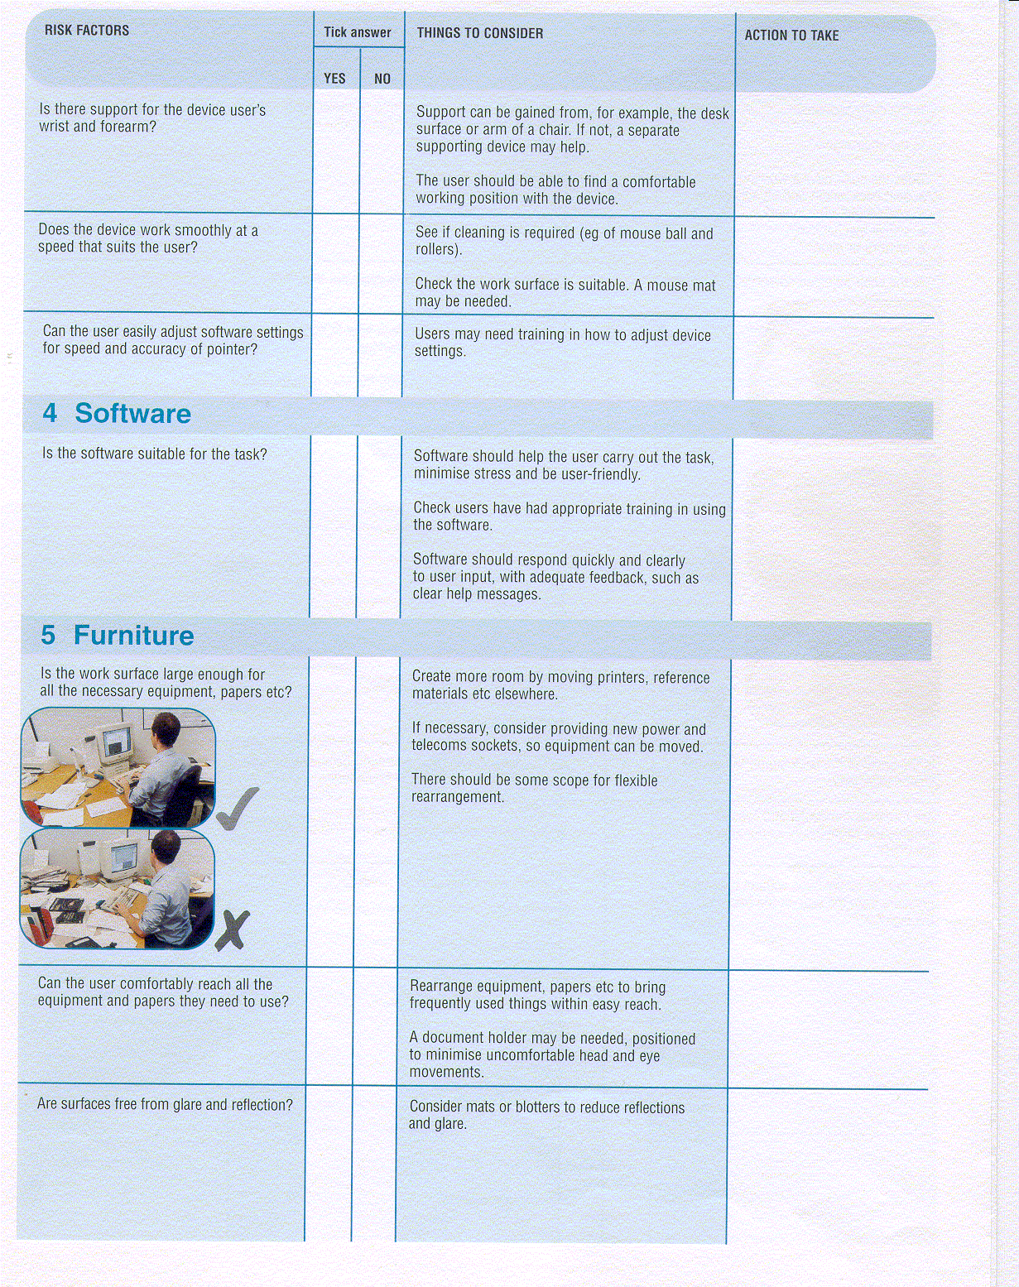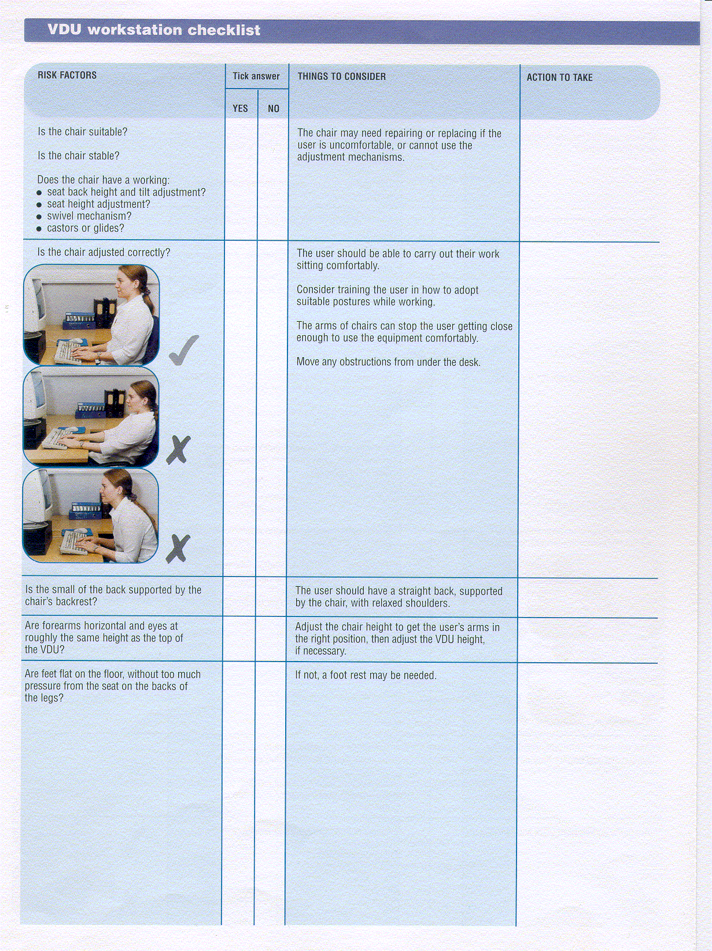

Insert any further details:

* **Have you already experienced discomfort whilst working at your display screen?** **YES/NO** If ‘yes’ make the required adjustments and monitor whether these have made a difference.
* **Do you take regular breaks away from your display screen? YES/NO** If ‘no’ ensure that you take a break of at least 5 minutes in each half hour.
* **Do you know that you should not work for long periods of time on a laptop without use of a docking station, separate keyboard and mouse? YES/NO** If you need to use a laptop, then ensure that you don’t make this your preferred workstation choice, or consider purchasing your own docking station, separate keyboard and mouse as these provide you with greater flexibility to achieve a comfortable working posture.
* **Were you aware that you will need to make adjustments at each different workstation before you start work? YES/NO** If ‘no’, then follow the same principle as when you sit in a car to drive after someone else has driven it – you adjust the car to suit you – the same principles apply to setting up your workstation. Make the adjustments and then start working.

**Write further details and any problems here:**

